

Medical Waste Management Plan
For compliance with the State of California Medical Waste Management Act California Health and Safety Code, Division 20, Chapter 4 and Part 14

Version: | v1
Created on: | 9/26/22
Revision Date:
Committee Approval: | PB
Approval Dates: | 9/26/22; 09/2024;

Facility Information

Medical Facility Address:
Millie Clinic - All Locations
Authorized Representative
Patricia Bevitz- Director, Clinical Operations
patricia@millieclinic.com
Ph: 510-495-0310

- Introduction
In accordance with Sections 117935 and 117960 of the California Health and Safety Code (HSC), as a small quantity generator our facility has developed and will maintain this Medical Waste Management Plan. The Medical Waste Management Plan establishes procedures and methods for the proper collection and storage of medical waste for transfer by a registered waste hauler to off-site treatment centers. All Millie clinic locations are considered small quantity waste generators as the amount of medical waste and sharps collected onsite does not exceed 200 pounds per month. The committee certifies that the information provided in this document is complete and correct.

- Policy
It is the policy of all Millie clinic locations, to ensure the health and safety of all of its employees. The Medical Waste Management Plan has been developed to protect personnel by eliminating or minimizing their exposure to medical waste and sharps collected onsite, and to comply with the California Medical Waste Management Act (California Health and Safety Code, Division 20, Chapter 4 and Part 14). Any potential exposures to untreated medical or biohazardous waste or sharps injuries must be reported immediately to the Director of Clinical Operations and Clinical Director at Millie.
The Millie policy is that all biohazardous or medical waste will be properly contained and stored onsite in appropriate containers until transferred off-site for treatment by a registered waste hauler.

- Containment and Storage Requirements for Medical Waste

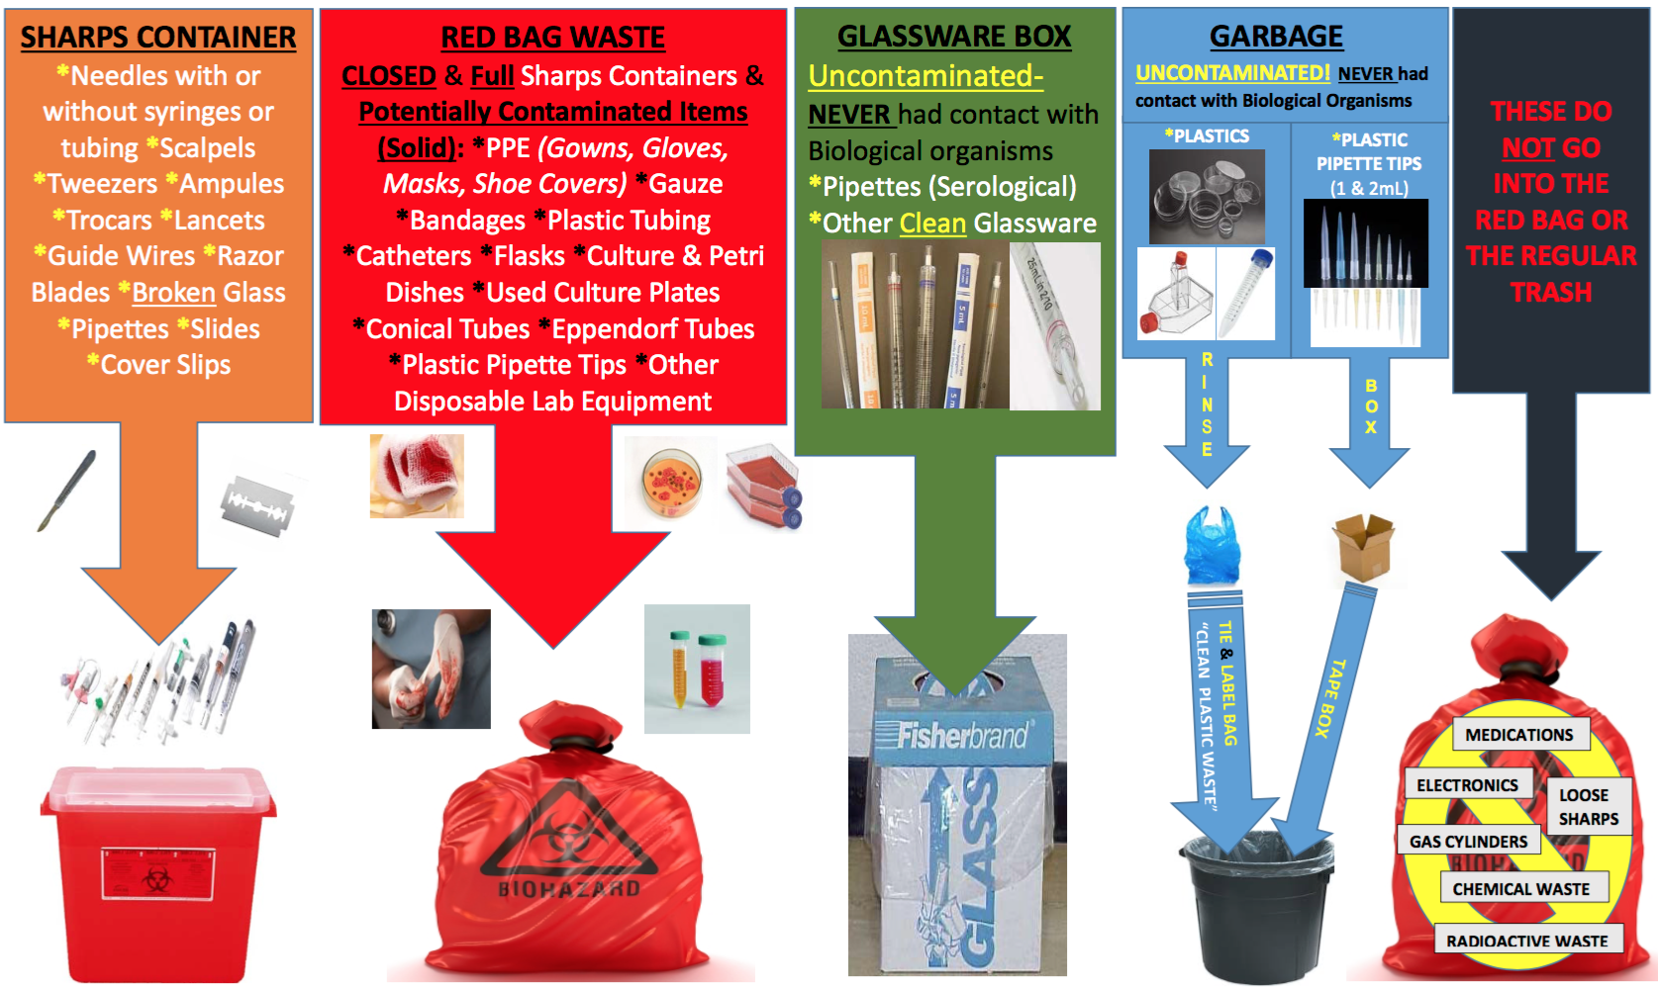

Solid Waste
Solid Medical or Biohazardous Waste Solid medical waste must be contained at the point of generation in red biohazard bags (orange biohazard bags are illegal in California), separate from other types of waste. Biohazard bags must be manufacturer certified to meet the ASTM D1709 dart drop test, provided that when the bag is prepared for transport offsite, it is placed into a USDOT-approved container lined with a biohazard bag that is ASTM D1709 and ASTM D1922 certified. Biohazard bags must be tied closed and placed in rigid containers with a tightly fitting lid, which must be labeled with “Biohazardous Waste” or “Biohazard” and the International Biohazard Symbol on the lid and sides, visible from any direction. It is recommended that medical waste be placed in double red bags to prevent spills if the primary bag fails.

Sharps
All sharps waste must be contained in sharps containers that are red, rigid and leak-proof with the words “sharps waste” or the International Biohazard Symbol and the word “biohazard” on the sharps container. Sharps containers are provided by Allied, our off-site medical waste hauler or through McKesson. Sharps containers must not be filled more than ¾ full and must be taped closed or tightly-lidded to prevent the loss of contents. Sharps containers must be picked up by Allied for transportation off-site.

Storage and Disposal of Intact Pipettes and Pipette Tips
Due to the small amount of pipette and pipette tips used at Millie facilities, they may be disposed of in the sharps containers.

Storage Area of Biohazardous and Medical Waste
The storage area used for biohazardous and medical waste accumulation must be secured to prevent access by unauthorized persons. Warning signs must be posted on entry doors. These warning signs must be in both English and Spanish and must state “CAUTION HAZARDOUS WASTE STORAGE-UNAUTHORIZED PERSONS KEEP OUT” and “CUIDADOZONA DE RESIDUOS-BIOLOGICOS PELIGROSOS-PROHIBIDA LA ENTRADA A PERSONAS NO AUTHORIZADAS.” Signs must be readily legible during daylight from a distance of at least 25 feet. Storage areas must be secured to deny access to unauthorized persons, animals, insects, wind and rain.
One 24 gallon plastic storage container with a tightly sealed lid is provided for each location to store any waste or sharps collected from exam rooms.

Storage Length of Time
Maximum storage time for biohazardous and medical waste and filled sharps containers is seven (7) days at a temperature not to exceed 32 degrees Fahrenheit (zero (0) degrees Celsius). This seven (7) day period begins when any waste has been placed in the container. Biohazardous and medical waste may be stored for a maximum of ninety (90) days at or below 32 degrees Fahrenheit or 0 degrees Celsius. The 90-day period begins when any waste has been placed in the container. If the materials are stored at or below 32 degrees Fahrenheit or 0 degrees Celsius, the freezers must have the temperature checked weekly to ensure that they are functioning properly.
Contact Allied USA at 855.597.4733 to schedule additional pickups if needed.

- Decontamination of Leaks and Spills
Decontamination of Leaks or Spills Any leak or spill of biohazardous or medical waste must be decontaminated using one of the following disinfectants for a minimum of 15-minutes contact time:
• Hypochlorite solution (500 ppm available chlorine)
• Phenolic solution (500 ppm of active agent)
• Iodoform solution (100 ppm available iodine)
• Quaternary ammonium solution (400 ppm active agent)
Proper gloves and/or PPE should be worn at all times when handling or cleaning biohazardous spills or leaks.
Please contact the Clinical Operations Director for assistance or questions.

Decontamination of Reusable Secondary Containers
Reusable secondary containers (garbage cans, bins, etc.) at Millie are lined with disposable material and removed with the waste, therefore not required to be cleaned after each use.
In the event a bin or container is used without proper lining or covering, the following methods will be used to properly clean the container after each use:
• Exposure to hot water of at least 82 degrees Centigrade (180 degrees Fahrenheit) for a minimum of fifteen (15) seconds
• Exposure to chemical sanitizer by rinsing with, or immersion in, one of the following for a minimum of three (3) minutes:
Hypochlorite solution (500 ppm available chlorine)
Phenolic solution (500 ppm of active agent)
Iodoform solution (100 ppm available iodine)
Quaternary ammonium solution (400 ppm active agent)

- Emergency Action Plan
In the event of a natural disaster, all medical waste will be suspended until adequate medical waste pickup is guaranteed and available. Additional contingency plans for emergency situations (natural disasters, etc.) would be to contact the Berkeley Department of Environmental Health, Emergency Services:
(510) 981-5605
For non-urgent matters or assistance you can contact the Director of Clinical Operations for guidance at patricia@millieclinic.com.

- Offsite Medical Waste Vendor Information
Allied USA - Medical Waste Hauler
Ph: 855.597.4733
In addition to weekly pick-ups for off-site transfer, staff can contact the vendor for pick-ups or supplies as needed.

- Medical Waste Tracking - Pickup Tracking
All medical waste tracking and treatment records must be kept for a minimum of 3 years

- Training
Personnel handling medical waste must be properly trained. Training must include:
Bloodborne Pathogens Training:
• Definitions
• Regulatory Requirements
• Biosafety Levels
• Bloodborne Pathogens
- Modes of Transmission
- Exposure Information
- Hepatitis A, B, C
- HIV
• Exposure Control Plan
• Post Exposure Evaluation
• Sharps Injury Log
• Emergency Response
• Biohazardous Waste Management

Medical Waste Training:
• Definition of Medical Waste
• Millie Medical Waste Management Plan Review

Safe Work Practices
• Selection and Use of Personal Protective Equipment (PPE)
• Signs and Labels
• Collection, Treatment and Disposal of Medical Waste
• Use of appropriate Personal Protective Equipment (PPE)
• Follow Standard Operating Procedures (SOPs)
• Use good personal hygiene

